**Sensor Impact Evaluation and Verification Framework for Fault Detection and Diagnostics (FDD): Evaluating the Impact of Sensor Accuracy on Sensor Selection**

Liang Zhang, Matt Leach

National Renewable Energy Laboratory

# 1. Introduction

Although many FDD papers have studied the topics of sensor selection and sensor accuracy, there is a lack of studies that systematically quantify sensor impact on FDD performance or overall building performance. Quantified sensor impact can better guide sensor design, selection, and placement for FDD applications. As a result, a framework to evaluate sensor impact on FDD performance, and to further evaluate the impact of FDD performance on building performance, such as energy efficiency and thermal comfort, is greatly needed. With such a framework, the sensor configurations of FDD applications can be directly evaluated in terms of building energy efficiency and thermal comfort, guiding more purposeful design, selection, placement and evolution of FDD sensors.

Two major aspects of sensor impact, sensor accuracy and sensor selection, have been evaluated separately for FDD and building performance in our FY20 Q4 report. However, they are not independent from each other: sensor accuracy affects sensor selection. The impact of sensor inaccuracy on the sensor selection process has not been quantified or analyzed. Evaluating the impact of sensor accuracy on sensor selection is the next step in refining the framework developed in FY20 Q4.

Our main task in this quarter has been to explore the impact of sensor accuracy on sensor selection. We developed two parallel methods, one probabilistic and one deterministic, to quantify that impact. The probabilistic method covers different sensor types (temperature sensor, humidity sensor, power meter, etc.) and sensor fault types (bias, drifting, precision degradation, and complete failure). The assumed probabilities are summarized via a probability table (Table 1). Based on the probability table, Monte Carlo simulation is conducted to generate multiple decisive results. From the decisive results, impact of fault occurrence and severity can be measured. The deterministic method is more straightforward: for each sensor, inaccuracy is injected with increasing severity. The threshold value beyond which the FDD algorithm stops selecting the sensor indicates how sensor inaccuracy impacts sensor selection results. Additionally, the degradation in FDD performance corresponding to the increasingly inaccurate (and ultimately deselected) sensor can be tracked. The probabilistic method focuses on a set of sensors as a whole, with a distribution of concurrent sensor faults across the set, whereas the deterministic method focuses on individual sensors. The two methods are designed to complement each other, combining to facilitate a comprehensive analysis of the impact of sensor inaccuracy on sensor selection. A case study is conducted to demonstrate these two methods using a commercial building model calibrated to Oak Ridge National Laboratory’s two-story Flexible Research Platform (FRP).

Section 2 introduces the probabilistic and deterministic methods of analyzing the impact of sensor inaccuracy on sensor selection in detail. Section 3 details the FRP case study of the developed workflow. Section 4 summarizes the results and findings of the case study. Section 5 presents conclusions and summarizes future work.

# 2. Analysis Framework for Evaluating the Impact of Sensor Accuracy on FDD Sensor Selection

Sensor faults (including various forms of inaccuracy) are common in building sensors and building automation systems; such faults can impact the data-driven FDD sensor selection process. While it is reasonable to expect that some effort would be made to ensure that a sensor set is well calibrated prior to FDD algorithm training, no real-world data set is perfect and data quality assessment for machine learning purposes is not generally straightforward. Additionally, for streaming machine learning applications, where algorithms are retrained on a rolling basis, it is unlikely that sensors would be recalibrated at every training interval.

If a sensor typically selected as a feature by an FDD algorithm has failed (i.e., reads constant numeric values or reports a non-numeric error code), the data-driven FDD algorithm will not select it as a feature. In a less extreme case, where a sensor has some form and magnitude of inaccuracy but is not in a state of complete failure, the FDD algorithm may or may not choose to select it as a feature. And if it is selected, its inaccuracy may result in degradation of FDD detection and diagnosis performance. FDD algorithm performance may be very sensitive to the accuracy of certain sensors; in such cases, sensors should be carefully selected and calibrated when leveraged for FDD purposes. In other cases, sensor inaccuracy may not have much effect on feature selection or overall FDD performance.

Quantifiable analysis is needed to evaluate these types of scenarios, which are common in the engineering practice of sensor selection and design. There are few studies that focus on the implications of sensor inaccuracy on FDD feature selection and performance. In this section, two methods to address this gap are presented: a probabilistic method and a deterministic method.

## 2.1. Probabilistic Method

Building sensors malfunction and fail stochastically. Different sensor types have different robustness and malfunction rates; enthalpy sensors and humidity sensors are less reliable than temperature sensors. Moreover, the probabilities of malfunction types vary from sensor to sensor. For example, complete failure of a temperature sensor may be less likely to happen than drifting or bias.

There are multiple potential sources of sensor accuracy uncertainty:

* Is the sensor faulty or operating normally?
* If the sensor is faulty, what is the type (bias, drifting, precision degradation, or complete failure) of fault?
* What is the severity, or magnitude, of the fault?

And each of these questions may depend on the sensor type (temperature, humidity, enthalpy, etc.). For each sensor type, the answers to these questions can be represented with probability distributions. We use the fault probability table structure presented in Table 1 to capture the likelihoods of the resulting combinations.

Table 1. Probability Table of Sensor Fault Types

| **Sensor Type/Sensor Fault Type** | **Failure P(B1)** | **Bias P(B2)** | **Drifting P(B3)** | **Precision Degradation P(B4)** |
| --- | --- | --- | --- | --- |
| Power Meter, P(A1) | P(A1|B1) | P(A1|B2) | P(A1|B3) | P(A1|B4) |
| Flow Meter, P(A2) | P(A2|B1) | P(A2|B2) | P(A2|B3) | P(A2|B4) |
| Thermometer, P(A3) | P(A3|B1) | P(A3|B2) | P(A3|B3) | P(A3|B4) |
| Differential pressure sensor, P(A4) | P(A4|B1) | P(A4|B2) | P(A4|B3) | P(A4|B4) |
| Enthalpy Sensor, P(A5) | P(A5|B1) | P(A5|B2) | P(A5|B3) | P(A5|B4) |
| … | … | … | … | … |

The probabilities P(A1), P(A2), etc. represent how robust each sensor type is. If P(A1) is equal to 0.1, that means that a power meter has a 10% chance to be faulty (for purposes of the sensor selection and FDD modeling process). More robust sensor types will have lower values; those prone to faulty operation will have higher values. For example, enthalpy sensors are generally less reliable, so P(A5) will have a relatively larger value than that for other sensor types. The probabilities P(B1), P(B2), etc. capture how likely certain sensor fault types are to occur. For example, the probability of complete failure P(B1) should be less than the probability of sensor bias P(B2), which is a very common sensor fault. Finally, conditional probabilities, in the form of P(An|Bn), capture the likelihood of a specific fault type (bias, drifting, precision degradation, or complete failure) when a fault is present for a certain sensor type. For example, P(A1|B1) is the probability that a faulty power meter sensor is experiencing complete failure.

We can sample the probability distribution space represented in the probability table structure to simulate potential combinations of sensor set inaccuracy. Since the sampling is random, the exact combination of fault states varies for each simulation. In this framework, Monte Carlo simulation is conducted to sample the probability distribution space sufficiently to comprehensively assess the impact of sensors faults on FDD performance. Monte Carlo methods, or Monte Carlo experiments, are a broad class of computational algorithms that rely on repeated random sampling to obtain numerical results. The underlying concept is to use randomness to solve problems that might be deterministic in principle. Monte Carlo methods are often used in physical and mathematical problems and are most useful when it is difficult or impossible to use other approaches. Monte Carlo methods are mainly applied to three problem classes: optimization, numerical integration, and generating draws from a probability distribution. In other words, Monte Carlo simulations are used to model the probability of different outcomes for a process where those outcomes cannot easily be predicted due to the influence of random variables. It is a technique used to understand the impact of risk and uncertainty in prediction and forecasting models.

For each iteration of the Monte Carlo simulation, a decisive sensor fault result is generated from the probability table and we select the most important sensors (e.g., top ten) selected as features by the FDD algorithm. The process is repeated n times, and after summarizing all n simulations, we can generate a probability table that summarizes the likelihood of each sensor being selected as a feature, and also a corresponding probability distribution of FDD performance. Figure 1 shows how Monte Carlo simulation driven by a fault probability table captures the uncertainty associated with sensor selection and predicts the corresponding impact on FDD performance.

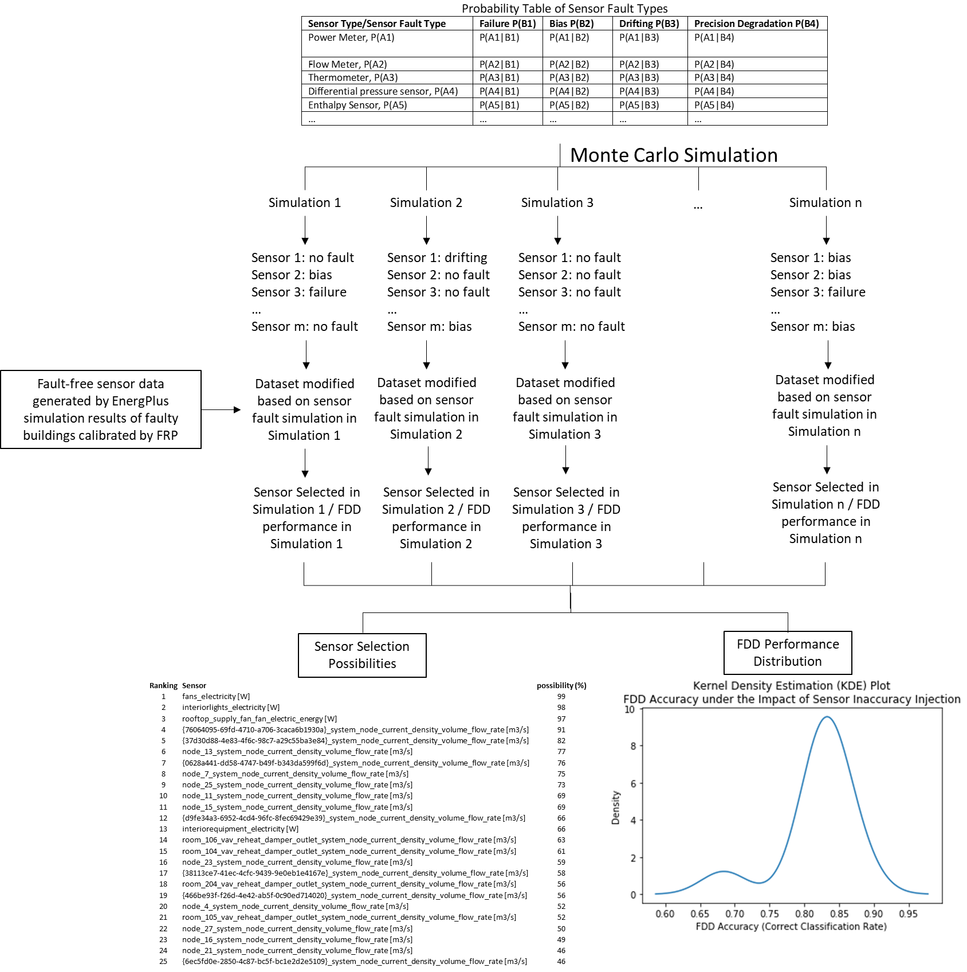

Figure . Diagram of how Monte Carlo simulation driven by a fault probability table predicts sensor selection and resulting FDD performance

## 2.2. Deterministic Analysis

To complement the probabilistic analysis described in Section 2.1, a simpler deterministic analysis is applied in parallel.

For each sensor, inaccuracy is injected with increasing intensities. The threshold beyond which the FDD algorithm stops selecting the sensor as a feature is the indicator of how sensor inaccuracy impacts sensor selection results. For each type of inaccuracy, we start at a minimum intensity and then increase the intensity until the sensor is no longer selected as a feature. The final threshold value is then recorded as a measure of how robust a sensor is to feature selection. Higher threshold values indicate either that the algorithm relies heavily on a particular sensor, or that FDD performance is relatively unaffected by the presence of inaccuracy for that sensor, or both. We can also measure the impact of increasing sensor inaccuracy on overall FDD performance to help differentiate between these two cases. The primary output of this deterministic method is a table of threshold values for each sensor. Figure 2 shows the pseudocode of the developed deterministic analysis

|  |
| --- |
| Algorithm: Deterministic Analysis of Sensor Inaccuracy Impact on Sensor Selection |
| 1 Iterate through all candidate sensors for FDD modeling:  2 The current sensor in this iteration is marked as ***sensor_n***  3 The initial sensor fault intensity injected to the ***sensor_n*** is ***current_inaccuracy*** *=*  ***initial_inaccuracy***  4 ***inaccuracy_interval*** is the value that gradually added to the ***current_inaccuracy*** in each iteration  5 Train the data-driven FDD model based on the fault-injected data. The fault intensity injected is ***current_inaccuracy***  6 Calculate selected sensor list by FDD model and check whether ***Sensor_n*** is in the list  7 While ***Sensor_n*** is still in the selected sensor list by FDD model:  8 ***current_inaccuracy*** = ***current_inaccuracy*** + ***inaccuracy_interval***  9 Repeat Line 5 to Line 6  10 ***threshold_n*** is the sensor inaccuracy threshold of ***sensor_n*** that just make ***sensor_n*** not selected by FDD algorithm  11 Record the ***threshold_n*** for each sensor  12 The list that contains all ***threshold_n*** for each sensor is the output of the developed algorithm |

Figure . Pseudocode of the developed deterministic analysis

The probabilistic method focuses on the net impact of fault states across a full sensor set, whereas the deterministic method focuses on individual sensors. The two methods complement each other, combining to provide a more comprehensive understanding of the impact of sensor inaccuracy on sensor selection. The next section details a case study that demonstrates the application of these two methods using a commercial building model calibrated to ORNL’s FRP experimental facility.

# 3. Case Study

This section details a case study conducted to demonstrate the analysis framework introduced in Section 2. The virtual testbed that simulates faulty buildings and generates simulation data is introduced in Section 3.1. The detailed simulated faults are introduced in Section 3.2. The data generated by the faulty building simulations are introduced in Section 3.3. Details of the machine learning based FDD modeling workflow are introduced in Section 3.4. The detailed settings for the probabilistic and deterministic analyses are introduced in Section 3.5 and Section 3.6, respectively.

## 3.1. Virtual Testbed

In this case study, a virtual testbed simulates faulty buildings and generates simulation data. The virtual testbed is a calibrated EnergyPlus [1] model of Oak Ridge National Laboratory’s two-story FRP [2, 3]. The FRP is a small-sized (3,200 ft2) commercial building that has a single packaged rooftop unit (RTU) connected to a multi-zone VAV system. The FRP is designed to imitate the construction and operation of a 1980s-era small office building typical of the southeastern United States. The RTU is a 12.5-ton unit that includes a natural-gas heating coil and the connected VAV system serves a total of 10 zones (8 perimeter and 2 core) with electric resistance reheat. Table 2 shows more details of the building characteristics. Figure 3 shows an exterior view of the facility and a rendering of the virtual testbed. Figure 4 shows the building floorplan (left) and HVAC system layout (right). More details about the testbed can be found in [4].

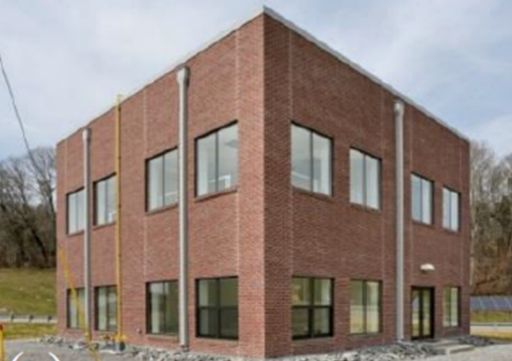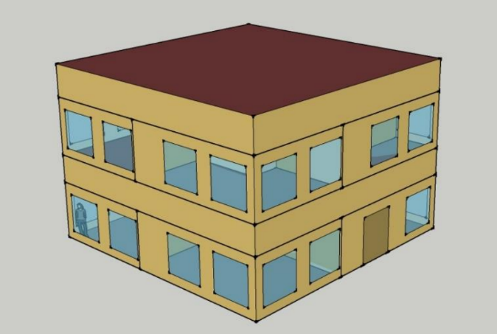

Figure . Virtual testbed modeled in EnergyPlus (right), calibrated to Oak Ridge National Laboratory’s Flexible Research Platform (left) [3]

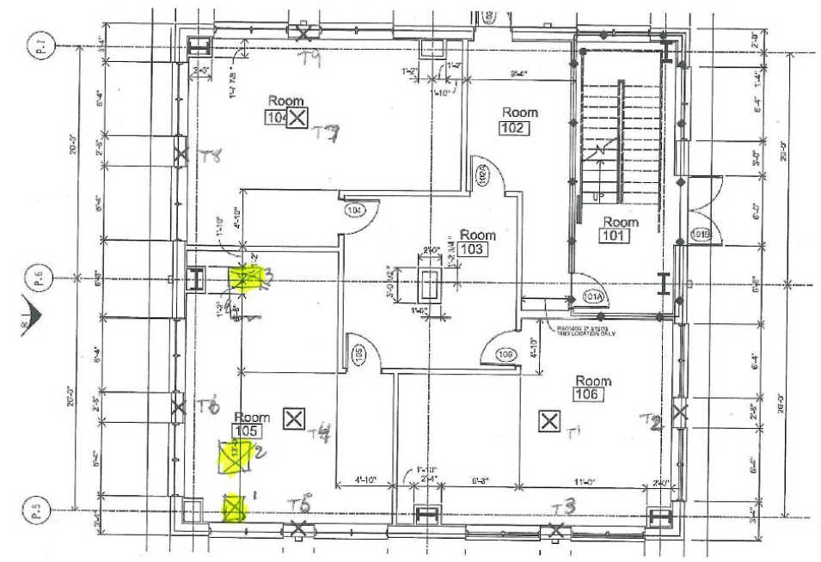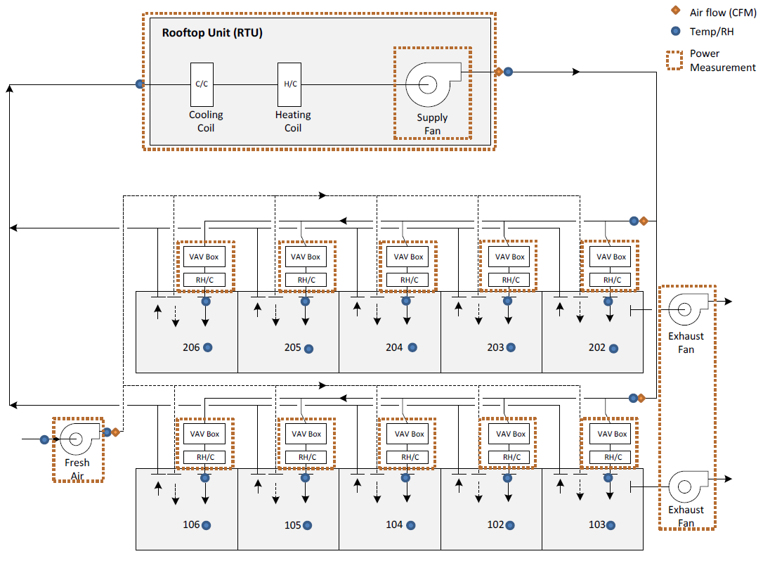

Figure . Building floorplan and HVAC system layout of Oak Ridge National Laboratory’s Flexible Research Platform (Source: [4])

Table . Building, construction, and system details of the virtual testbed (Source: [3])

|  |  |
| --- | --- |
| **General characteristics** | |
| Building width | 12.2 m |
| Building length | 12.2 m |
| Story height | 4.3 m |
| Number of floors | 2 |
| Number of thermal zones | 10 (8 perimeter and 2 core) |
| **Construction characteristics** | |
| Wall structure | Concrete masonry units with face brick |
| Wall insulation | Fiberglas RSI-1.9 (W/m-K) |
| Floor | Slab-on-grade |
| Roof structure | Metal deck with polyisocyanurate and ethylene propylene diene monomer |
| Roof insulation | Polyisocyanurate RSI-3.17(W/m-K) |
| Windows | Aluminum frame, double-pane, clear glazing |
| Window-to-wall ratio | 28% |
| **Systems and equipment characteristics** | |
| Lighting power density | 9.2 W/m2 with lighting on/off schedule |
| Equipment power density | 14.0 W/m2 with on/off schedule |
| Baseline systems | Rooftop variable-air-volume unit with electric reheat, natural gas furnace |
| Rooftop unit (RTU) cooling capacity | 43.74 kW |
| RTU efficiency | 9.7 energy efficiency ratio (EER) |
| Natural gas furnace efficiency | 81% annual fuel utilization efficiency (AFUE) |

## 3.2 Simulated Faults

To generate a data set for evaluation of the developed analysis framework, 26 faults with multiple fault intensities are simulated in the virtual testbed (Table 3). Each fault model is applied via a model perturbation script that modifies the OpenStudio wrapper for the EnergyPlus model (https://github.com/NREL/OpenStudio-fault-models). The fault model development and simulation details can be found in [5, 6]. The fault models substitute faulted conditions for normal operating condition; faults are modeled as present for the entire simulation period. Fault intensity levels are determined based on either application ranges that are defined in the experimental measurements (for training fault models) or reasonable ranges that are acquired from a literature review [7]. The detailed fault intensity introduction and definition can be found in our previous study [5, 6]. A total of 99 faulted scenarios are considered for 26 fault models. Each scenario is simulated for seven different weather conditions: six typical meteorological year (TMY) weather files and one actual meteorological year (AMY) weather file (listed in Table 4). Thus, a total of 700 simulations (99 faulted scenarios and 1 non-faulted scenario for 7 different weather conditions) are simulated. Multiple weather files were selected for training to cover a variety of climate zones, including zones with extreme weather conditions outside the range of those expected to be experienced by the target building. This helps ensure that all possible test scenarios are fully represented. The locations chosen include a hot, arid location (Riyadh); a cold, dry location (Fairbanks); a hot, humid/ tropical location (Miami); a cold, humid location (Duluth), and mixed-humid locations (Louisville, Richmond, and Knoxville).

Table . Simulated fault model types and intensities

|  |  |  |  |
| --- | --- | --- | --- |
| **No.** | **Fault type** | **Fault intensity definition** | **Fault intensity [5, 6]** |
| 1 | Condenser fan degradation | reduction in motor efficiency as a fraction of the non-faulted motor efficiency | 0.1, 0.167, 0.233, 0.3 |
| 2 | Condenser fouling | ratio of reduction in condenser coil airflow at full load | 0.1, 0.233, 0.367, 0.5 |
| 3 | Nonstandard refrigerant charging: overcharge | ratio of charge deviation from the normal charge level | 0.0375, 0.075, 0.1125, 0.15 |
| 4 | Nonstandard refrigerant charging: undercharge | ratio of charge deviation from the normal charge level | -0.3, -0.225, -0.15, -0.075 |
| 5 | Presence of non-condensable in refrigerant | ratio of the mass of non-condensable in the refrigerant circuit to the mass of non-condensable that the refrigerant circuit can hold at standard atmospheric pressure | 0.1, 0.267, 0.433, 0.6 |
| 6 | Refrigerant liquid-line restriction | ratio of increase in the pressure difference between the condenser outlet and evaporator inlet due to the restriction | 0.1, 0.167, 0.233, 0.3 |
| 7 | Thermostat measurement bias | thermostat measurement bias in °C | -3, -1, 1, 3 |
| 8 | Improper time delay setting in occupancy sensors | delayed time setting in hours | 0.25, 0.5, 0.75 |
| 9 | Lighting setback error: delayed onset | delay in the onset of overnight lighting setback in hours | 1, 2, 3, |
| 10 | Lighting setback error: early termination | early termination of overnight lighting setback in hours | 1, 2, 3 |
| 11 | Lighting setback error: no overnight setback | absence of overnight lighting setback | All days, Weekdays only, Weekend only |
| 12 | Oversized equipment at design | ratio of increased sizing compared to the correct sizing | 0.1, 0.233, 0.367, 0.5 |
| 13 | HVAC setback error: delayed onset | delay in onset of overnight HVAC setback in hours | 1, 1.667, 2.333, 3 |
| 14 | HVAC setback error: early termination | early termination of overnight HVAC setback in hours | 1, 1.667, 2.333, 3 |
| 15 | HVAC setback error: no overnight setback | absence of overnight HVAC setback | All days, Weekdays only, Weekend only |
| 16 | Excessive infiltration around the building envelope | ratio of excessive infiltration around the building envelope compared to the non-faulted condition | 0.1, 0.2, 0.3, 0.4 |
| 17 | Outdoor air damper stuck at certain position | ratio of outdoor air damper at the stuck position | 0, 0.333, 0.666, 0.1 |
| 18 | Return air duct leakages | unconditioned air introduced to return air stream at full load condition as a ratio of the total return airflow rate | 0.1, 0.167, 0.233, 0.3 |
| 19 | Supply air duct leakages | ratio of the leakage flow relative to supply flow | 0.1, 0.167, 0.233, 0.3 |
| 20 | AHU fan motor degradation | ratio of fan motor efficiency degradation | 0.1, 0.167, 0.233, 0.3 |
| 21 | Duct fouling | reduction in evaporator coil airflow at full load condition as a ratio of the design airflow rate | 0.1, 0.2, 0.3, 0.4 |
| 22 | Biased sensor: mixed air temperature | biased temperature level in °C | -3, -1, 1, 3 |
| 23 | Biased sensor: outdoor relative humidity (RH) | biased RH level in % | -10, -5, 5, 10 |
| 24 | Biased sensor: outdoor air temperature | biased temperature level in °C | -3, -1, 1, 3 |
| 25 | Biased sensor: return RH | biased RH level in % | -10, -5, 5, 10 |
| 26 | Biased sensor: return air temperature | biased temperature level in °C | -3, -1, 1, 3 |

Table . Seven weather files for virtual testbed simulation

|  |  |  |  |
| --- | --- | --- | --- |
| **No.** | **Locations** | **ASHRAE Climate Zone** | **Weather file** |
| 1 | Riyadh, Saudi Arabia | Zone 1B, very hot, dry | SAU_Riyadh.404380_IWEC.epw |
| 2 | Fairbanks, Alaska, USA | Zone 8, subarctic | USA_AK_Fairbanks.Intl.AP.702610_TMY3.epw |
| 3 | Miami, Florida, USA | Zone 1A, very hot, humid | USA_FL_Miami.Intl.AP.722020_TMY3.epw |
| 4 | Louisville, Kentucky, USA | Zone 4A, mixed-humid | USA_KY_Louisville-Standiford.Field.724230_TMY3.epw |
| 5 | Duluth, Minnesota, USA | Zone 7, very cold | USA_MN_Duluth.Intl.AP.727450_TMY3.epw |
| 6 | Richmond, Virginia, USA | Zone 4A, mixed-humid | USA_VA_Richmond.Intl.AP.724010_TMY3.epw |
| 7 | Knoxville, Tennessee, USA* | Zone 4A, mixed-humid | USA_TN_Knox_2016_AMY.epw |

*AMY weather file for testing. Others are TMY weather files.

There are two limitations of the fault simulation method used. First, only one fault can be present at a time; cases where multiple faults occur simultaneously are not considered. Second, the simulated fault does not change or evolve; that is, fault intensity remains constant throughout the simulation period.

## 3.3. Data for Training, Validation, and Testing

Data used for data-driven modeling are collected from virtual sensors in the EnergyPlus model. The sampling interval for the virtual sensors is 15 minutes. A total of 189 virtual sensors are considered in this study. The sensors are grouped into “moderate”, “rich” and “advanced” sensor sets, in order of decreasing likelihood of being incorporated into typical building automation systems. The forty-six moderate sensors in the virtual testbed are listed in Table 5.

Table . Virtual sensors in the “moderate” group in the virtual testbed

|  |  |
| --- | --- |
| **No.** | **Virtual sensors [unit]** |
| 1 | electricity facility [W] |
| 2 | whole building facility total HVAC electric demand power [W] |
| 3 | heating electricity [W] |
| 4 | interior equipment electricity [W] |
| 5 | interior lights electricity [W] |
| 6 | environment site outdoor air barometric pressure [Pa] |
| 7 | environment site outdoor air dry-bulb temperature [°C] |
| 8 | environment site outdoor air relative humidity [%] |
| 9 | environment site outdoor air wet-bulb temperature [°C] |
| 10 | environment site rain status |
| 11 | rooftop cooling coil air outlet temperature [°C] |
| 12 | rooftop heating coil air outlet temperature [°C] |
| 13 | rooftop mixed air temperature [°C] |
| 14 | rooftop discharge air temperature [°C] |
| 15-24 | supply reheat coil outlet air temperature [°C] (room 102, 103, 104, 105, 106, 202, 203, 204, 205, 206) |
| 25-34 | VAV reheat damper discharge air temperature [°C] (room 102, 103, 104, 105, 106, 202, 203, 204, 205, 206) |
| 35-46 | zone mean air temperature [°C] (room 101, 102, 103, 104, 105, 106, 201, 202, 203, 204, 205, 206) |

## 3.4. Settings of Data-Driven FDD Modeling

### 3.4.1. Inputs and Output of Data-Driven Model

The data-driven FDD model is a multiclass classification algorithm with 26 fault types (shown in Table 3) and one non-fault type (for a total of 27 classes). The algorithm represents an extension of the research presented in [8]. The inputs of the model are the extracted and selected features obtained from the available virtual sensors documented in Table 5. Model output is a class label corresponding to the non-faulted case or one of the 26 faults. Model output is generated for each day, which corresponds to the fault reporting interval.

### 3.4.2. Data-Driven Algorithm: Random Forest

Random forest is the data-driven algorithm used for FDD modeling in this study. Random forest is an ensemble method that builds predictive models for both classification and regression problems. Ensemble methods use multiple learning models to achieve better predictive results—in the case of a random forest, the model creates an entire forest of random uncorrelated decision trees and then applies a consensus algorithm to arrive at the best possible answer. Random forest has been applied to data-driven FDD research [8, 9]. In this study, the random forest algorithm is realized via scikit-learn (version 0.21.2), a Python package for machine learning [10]. The random forest parameter values are listed in Table 6. Most of the parameters are set to the default values in scikit-learn, except the estimator number, or the number of trees, which is decided by an unreported test which indicates that the random forest accuracy stops increasing when the number of trees reaches 250.

Table . Random forest parameters used in scikit-learn for FDD model

|  |  |  |
| --- | --- | --- |
| **Parameters [10]** | **Details [10]** | **Values** |
| estimator number | The number of trees in the forest | 250 |
| criterion | The function to measure the quality of a split | ‘gini’ |
| max features | The number of features to consider when looking for the best split | ‘sqrt’ |
| max depth | The maximum depth of the tree | None |
| min samples split | The minimum number of samples required to split an internal node | 2 |
| min samples leaf | The minimum number of samples required to be at a leaf node | 1 |
| min weight fraction leaf | The minimum weighted fraction of the sum of weights | 0 |
| max leaf nodes | Grow trees with max leaf nodes in best-first fashion. Best nodes are defined as relative reduction in impurity | None |
| min impurity split | Threshold for early stopping in tree growth | float |
| min impurity decrease | A node will be split if this split induces a decrease of the impurity greater than or equal to this value | 0 |

## 3.5 Settings of the Probabilistic Analysis

The probability table that captures the probability of each combination of sensor and fault type represents the key input to the probabilistic analysis. Specifying this set of inputs is critical to mapping out the resulting selection probabilities and corresponding FDD performance distribution. Extensive fault prevalence data would be required to accurately specify these inputs. For now, we applied the example set of inputs presented in Table 7 to evaluate the feasibility and potential of the probabilistic analysis framework. Our example set of inputs is very simple: (1) each sensor type has a 10% chance of faulted behavior; and (2) faulted behavior is evenly attributed to the possible fault types (sensor failure, sensor bias, sensor drifting and sensor precision degradation).

Table 7. Presumed probability table of sensor inaccuracy

|  |  |  |  |  |
| --- | --- | --- | --- | --- |
| **Sensor Type/ Sensor Fault Type** | **Failure P(B1)** | **Bias P(B2)** | **Drift P(B3)** | **Precision Degradation P(B4)** |
| Electricity meter, P(A1) = 0.1 | P(A1|B1) = 0.25 | P(A1|B2) = 0.25 | P(A1|B3) = 0.25 | P(A1|B4) = 0.25 |
| System node temperature sensor, P(A2) = 0.1 | P(A2|B1) = 0.25 | P(A2|B2) = 0.25 | P(A2|B3) = 0.25 | P(A2|B4) = 0.25 |
| Room temperature sensor, P(A3) = 0.1 | P(A3|B1) = 0.25 | P(A3|B2) = 0.25 | P(A3|B3) = 0.25 | P(A3|B4) = 0.25 |
| Energy meter, P(A4) = 0.1 | P(A4|B1) = 0.25 | P(A4|B2) = 0.25 | P(A4|B3) = 0.25 | P(A4|B4) = 0.25 |
| Weather meter, P(A5) = 0.1 | P(A5|B1) = 0.25 | P(A5|B2) = 0.25 | P(A5|B3) = 0.25 | P(A5|B4) = 0.25 |
| Room humidity sensor, P(A6) = 0.1 | P(A6|B1) = 0.25 | P(A6|B2) = 0.25 | P(A6|B3) = 0.25 | P(A6|B4) = 0.25 |
| System node flow rate, P(A7) = 0.1 | P(A7|B1) = 0.25 | P(A7|B2) = 0.25 | P(A7|B3) = 0.25 | P(A7|B4) = 0.25 |
| Gas meter, P(A8) = 0.1 | P(A8|B1) = 0.25 | P(A8|B2) = 0.25 | P(A8|B3) = 0.25 | P(A8|B4) = 0.25 |

For this set of inputs, independent Monte Carlo simulations are conducted for each weather location. The number of runs for each weather location is initially set to 100. For each run, a new machine learning model needs to be retrained; the resulting computational cost is high. With more computing power, we can increase the number of runs to pursue a more accurate result, but for now, the results are based on 100 runs.

## 3.6 Settings of the Deterministic Analysis

The simulation settings for the deterministic interaction between sensor accuracy and sensor selection have two parts. The first part decides what sensor types will be evaluated. As described in Section 2.2, we consider the sensors that initially rank high in the machine learning algorithm feature selection process. In this study, we inject inaccuracy to the top 10 (most impactful) sensors for each weather location. The second part determines how faults are injected into the sensor data. In the case study, we focused on sensor precision degradation as the injected sensor fault type. We first inject 5% of noise into the original sensor data. If the sensor is still selected as a feature, we increase the noise by an additional 5%, and continue to do so until the sensor is no longer selected. The 5% interval was chosen to align with our computational capabilities.

# 4. Results and Discussion

This section presents the results of the case study demonstration (introduced in Section 3) of the probabilistic and deterministic analyses (introduced in Section 2). For the probabilistic analysis , final results for sensor selection possibilities and FDD performance distribution across all seven weather locations are presented and summarized in Section 4.1. For the deterministic analysis, sensor selection threshold inaccuracies across all seven weather locations for the top 10 most important sensors are presented and summarized in Section 4.2

## 4.1. Probabilistic Analysis

As detailed in Section 2.1, the output of the probabilistic analysis consists of two parts: the sensor selection possibilities and the corresponding FDD performance distribution.

Table 8 through Table 14 show the 10 sensors with the highest probability of selection across the fault probability space mapped out by the probabilistic analysis; each table corresponds to a different weather location. We can see from the results that: (1) there is a clear correlation between feature selection and weather; (2) fan energy, gas consumption, and interior lighting are the most frequently selected sensors and rank high in terms of selection probability across all weather locations; (3) system node flow rate and room VAV reheat damper related sensors are also heavily selected; (4) room VAV reheat damper related sensors are heavily selected, and (5) most of the highest impact sensors are in the rich and advanced sensor groups, indicating that the moderate sensor set is insufficient for ensuring the best FDD performance.

Table 8. SAU_Riyadh, 10 sensors with highest probability to be selected

|  |  |  |  |
| --- | --- | --- | --- |
| **Ranking** | **Sensor** | **Sensor Group** | **Selected Possibility** |
| 1 | fans_electricity [W] | Rich | 99 |
| 2 | interiorlights_electricity [W] | Moderate | 95 |
| 3 | rooftop_supply_fan_fan_electric_energy [W] | Rich | 94 |
| 4 | node_6_system_node_current_density_volume_flow_rate [m3/s] | Advanced | 91 |
| 5 | node_19_system_node_current_density_volume_flow_rate [m3/s] | Advanced | 84 |
| 6 | node_7_system_node_current_density_volume_flow_rate [m3/s] | Advanced | 82 |
| 7 | room_203_supply_inlet_system_node_current_density_volume_flow_rate [m3/s] | Advanced | 77 |
| 8 | interiorequipment_electricity [W] | Moderate | 69 |
| 9 | heating_gas [W] | Rich | 68 |
| 10 | room_104_supply_inlet_system_node_current_density_volume_flow_rate [m3/s] | Advanced | 63 |

Table 9. TN_Knoxville, 10 sensors with highest probability to be selected

|  |  |  |  |
| --- | --- | --- | --- |
| **Ranking** | **Sensor** | **Sensor Group** | **Selected Possibility** |
| 1 | rooftop_supply_fan_fan_electric_energy [W] | Rich | 99 |
| 2 | room_104_vav_reheat_damper_outlet_system_node_current_density_volume_flow_rate [m3/s] | Rich | 98 |
| 3 | fans_electricity [W] | Rich | 96 |
| 4 | node_12_system_node_current_density_volume_flow_rate [m3/s] | Advanced | 95 |
| 5 | {6ec5fd0e-2850-4c87-bc5f-bc1e2d2e5109}_system_node_current_density_volume_flow_rate [m3/s] | Advanced | 93 |
| 6 | interiorlights_electricity [W] | Moderate | 92 |
| 7 | node_19_system_node_current_density_volume_flow_rate [m3/s] | Advanced | 91 |
| 8 | room_104_supply_inlet_system_node_current_density_volume_flow_rate [m3/s] | Advanced | 86 |
| 9 | room_203_vav_reheat_damper_outlet_system_node_current_density_volume_flow_rate [m3/s] | Rich | 82 |
| 10 | node_18_system_node_current_density_volume_flow_rate [m3/s] | Advanced | 81 |

Table 10. VA_Richmond, 10 sensors with highest probability to be selected

|  |  |  |  |
| --- | --- | --- | --- |
| **Ranking** | **Sensor** | **Sensor Group** | **Selected Possibility** |
| 1 | room_104_vav_reheat_damper_outlet_system_node_current_density_volume_flow_rate [m3/s] | Rich | 99 |
| 2 | fans_electricity [W] | Rich | 99 |
| 3 | room_204_vav_reheat_damper_outlet_system_node_current_density_volume_flow_rate [m3/s] | Rich | 98 |
| 4 | rooftop_supply_fan_fan_electric_energy [W] | Rich | 96 |
| 5 | interiorlights_electricity [W] | Moderate | 96 |
| 6 | {6ec5fd0e-2850-4c87-bc5f-bc1e2d2e5109}_system_node_current_density_volume_flow_rate [m3/s] | Advanced | 90 |
| 7 | node_19_system_node_current_density_volume_flow_rate [m3/s] | Advanced | 81 |
| 8 | {466be93f-f26d-4e42-ab5f-0c90ed714020}_system_node_current_density_volume_flow_rate [m3/s] | Advanced | 79 |
| 9 | {76064095-69fd-4710-a706-3caca6b1930a}_system_node_current_density_volume_flow_rate [m3/s] | Advanced | 76 |
| 10 | node_11_system_node_current_density_volume_flow_rate [m3/s] | Advanced | 75 |

Table 11. AK_Fairbanks, 10 sensors with highest probability to be selected

|  |  |  |  |
| --- | --- | --- | --- |
| **Ranking** | **Sensor** | **Sensor Group** | **Selected Possibility** |
| 1 | node_7_system_node_current_density_volume_flow_rate [m3/s] | Advanced | 99 |
| 2 | interiorlights_electricity [W] | Moderate | 97 |
| 3 | rooftop_supply_fan_fan_electric_energy [W] | Rich | 95 |
| 4 | fans_electricity [W] | Rich | 91 |
| 5 | node_11_system_node_current_density_volume_flow_rate [m3/s] | Advanced | 90 |
| 6 | node_6_system_node_current_density_volume_flow_rate [m3/s] | Advanced | 87 |
| 7 | node_25_system_node_current_density_volume_flow_rate [m3/s] | Advanced | 79 |
| 8 | {76064095-69fd-4710-a706-3caca6b1930a}_system_node_current_density_volume_flow_rate [m3/s] | Advanced | 76 |
| 9 | {466be93f-f26d-4e42-ab5f-0c90ed714020}_system_node_current_density_volume_flow_rate [m3/s] | Advanced | 68 |
| 10 | node_4_system_node_current_density_volume_flow_rate [m3/s] | Advanced | 67 |

Table 12. FL_Miami, 10 sensors with highest probability to be selected

|  |  |  |  |
| --- | --- | --- | --- |
| **Ranking** | **Sensor** | **Sensor Group** | **Selected Possibility** |
| 1 | node_6_system_node_current_density_volume_flow_rate [m3/s] | Advanced | 99 |
| 2 | fans_electricity [W] | Rich | 98 |
| 3 | interiorlights_electricity [W] | Moderate | 96 |
| 4 | room_104_supply_inlet_system_node_current_density_volume_flow_rate [m3/s] | Advanced | 93 |
| 5 | rooftop_supply_fan_fan_electric_energy [W] | Rich | 92 |
| 6 | node_7_system_node_current_density_volume_flow_rate [m3/s] | Advanced | 91 |
| 7 | node_11_system_node_current_density_volume_flow_rate [m3/s] | Advanced | 87 |
| 8 | {6ec5fd0e-2850-4c87-bc5f-bc1e2d2e5109}_system_node_current_density_volume_flow_rate [m3/s] | Advanced | 85 |
| 9 | room_104_vav_reheat_damper_outlet_system_node_current_density_volume_flow_rate [m3/s] | Rich | 82 |
| 10 | room_203_supply_inlet_system_node_current_density_volume_flow_rate [m3/s] | Advanced | 81 |

Table 13. KY_Louisville, 10 sensors with highest probability to be selected

|  |  |  |  |
| --- | --- | --- | --- |
| **Ranking** | **Sensor** | **Sensor Group** | **Selected Possibility** |
| 1 | rooftop_supply_fan_fan_electric_energy [W] | Rich | 100 |
| 2 | fans_electricity [W] | Rich | 99 |
| 3 | {6ec5fd0e-2850-4c87-bc5f-bc1e2d2e5109}_system_node_current_density_volume_flow_rate [m3/s] | Advanced | 99 |
| 4 | node_19_system_node_current_density_volume_flow_rate [m3/s] | Advanced | 94 |
| 5 | interiorlights_electricity [W] | Moderate | 94 |
| 6 | room_104_vav_reheat_damper_outlet_system_node_current_density_volume_flow_rate [m3/s] | Rich | 83 |
| 7 | room_204_vav_reheat_damper_outlet_system_node_current_density_volume_flow_rate [m3/s] | Rich | 80 |
| 8 | room_203_supply_inlet_system_node_current_density_volume_flow_rate [m3/s] | Advanced | 79 |
| 9 | interiorequipment_electricity [W] | Moderate | 78 |
| 10 | {76064095-69fd-4710-a706-3caca6b1930a}_system_node_current_density_volume_flow_rate [m3/s] | Advanced | 77 |

Table 14. MN_Duluth, 10 sensors with highest probability to be selected

|  |  |  |  |
| --- | --- | --- | --- |
| **Ranking** | **Sensor** | **Sensor Group** | **Selected Possibility** |
| 1 | interiorlights_electricity [W] | Moderate | 97 |
| 2 | rooftop_supply_fan_fan_electric_energy [W] | Rich | 93 |
| 3 | {76064095-69fd-4710-a706-3caca6b1930a}_system_node_current_density_volume_flow_rate [m3/s] | Advanced | 92 |
| 4 | fans_electricity [W] | Rich | 92 |
| 5 | {37d30d88-4e83-4f6c-98c7-a29c55ba3e84}_system_node_current_density_volume_flow_rate [m3/s] | Advanced | 89 |
| 6 | node_7_system_node_current_density_volume_flow_rate [m3/s] | Advanced | 80 |
| 7 | node_13_system_node_current_density_volume_flow_rate [m3/s] | Advanced | 78 |
| 8 | node_25_system_node_current_density_volume_flow_rate [m3/s] | Advanced | 76 |
| 9 | {0628a441-dd58-4747-b49f-b343da599f6d}_system_node_current_density_volume_flow_rate [m3/s] | Advanced | 71 |
| 10 | {d9fe34a3-6952-4cd4-96fc-8fec69429e39}_system_node_current_density_volume_flow_rate [m3/s] | Advanced | 69 |

Figure 5 shows the kernel density estimation (KDE) plots of FDD accuracy for the seven weather locations. The KDE plots represent the probability distribution of FDD accuracies for the fault space mapped out by the probabilistic analysis; each plot corresponds to a different weather location.

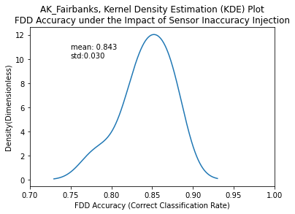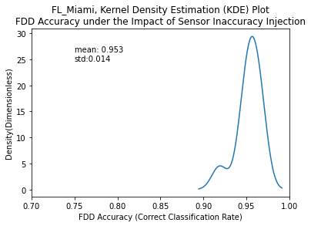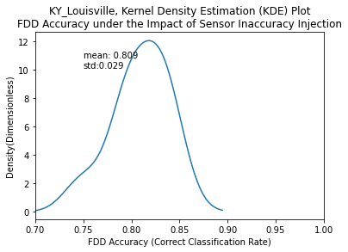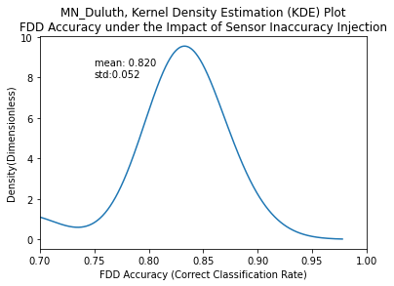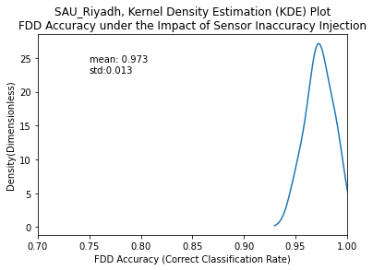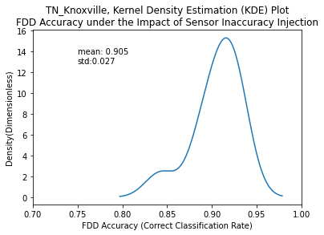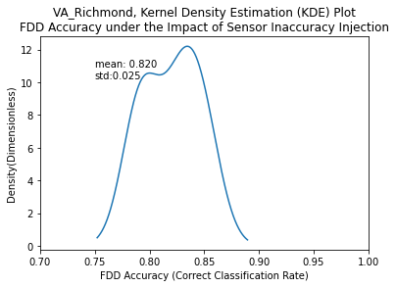

Figure 5. FDD performance distributions for the probabilistic analysis

## 4.2. Deterministic Analysis

For the deterministic analysis, we inject increasing fault intensity to each sensor until we reach a threshold value above which the sensor is no longer selected as a feature of the FDD algorithm. For example, if we want to calculate the sensor precision degradation threshold for interior lights power meter in Fairbanks, we first inject 5% of uncertainty or degraded precision into the sensor. If the sensor is still selected, we increase the uncertainty by 5%. We repeat this process until the sensor is no longer selected by the FDD algorithm. Finally, we calculate that the selection threshold for this meter is 25% in Fairbanks, indicating that even with 25% degraded precision, the FDD algorithm will still select this meter as a feature for FDD. The following figure shows the fault injection process and how it affects the FDD performance and sensor selection.

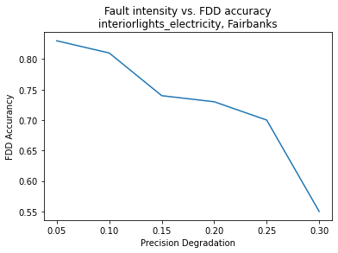

Turning Point

of sensor start not to be selected

Figure 6. The fault injection process and how it affects sensor selection and FDD performance

Table 15 through Table 21 report the precision degradation thresholds of the top 10 sensors for each of the seven weather locations. Selection threshold values various across a sensor set and for a given sensor across weather locations. There is not a clear correlation between sensor selection robustness and overall FDD performance. This is likely because the relationship between inaccuracy (and selection) and FDD performance varies from sensor to sensor. For some sensors, relatively high inaccuracies may have little influence on selection or FDD performance. Additionally, the selection threshold may correspond to a clear step in FDD performance (with a clear drop in performance corresponding to failure to select a sensor as a feature) in some cases, but not in others. More detailed analysis of the relationship between inaccuracy and selection/FDD performance at the individual sensor level is needed to identify trends in the results.

In general, because FDD models are black box in nature, it is difficult to leverage domain knowledge to interpret results. It is also worth mentioning that the results presented in Table 15 through Table 21 are only specifically applicable to the FRP and similar buildings: the purpose of the developed analysis is to demonstrate a generic methodology that is applicable to all buildings. We expect that conclusions related to sensor accuracy, selection, and FDD performance will be building specific.

Table 15. SAU_Riyadh, precision degradation threshold of top 10 sensors

|  |  |  |  |
| --- | --- | --- | --- |
| **No.** | **Sensor** | **Group** | **Threshold (%)** |
| 1 | fans_electricity [W] | Rich | 25 |
| 2 | interiorlights_electricity [W] | Moderate | 25 |
| 3 | rooftop_supply_fan_fan_electric_energy [W] | Rich | 45 |
| 4 | node_6_system_node_current_density_volume_flow_rate [m3/s] | Advanced | 40 |
| 5 | node_19_system_node_current_density_volume_flow_rate [m3/s] | Advanced | 15 |
| 6 | node_7_system_node_current_density_volume_flow_rate [m3/s] | Advanced | 45 |
| 7 | room_203_supply_inlet_system_node_current_density_volume_flow_rate [m3/s] | Advanced | 15 |
| 8 | interiorequipment_electricity [W] | Moderate | 20 |
| 9 | heating_gas [W] | Rich | 25 |
| 10 | room_104_supply_inlet_system_node_current_density_volume_flow_rate [m3/s] | Advanced | 30 |

Table 16. TN_Knoxville, precision degradation threshold of top 10 sensors

|  |  |  |  |
| --- | --- | --- | --- |
| **No.** | **Sensor** | **Group** | **Threshold (%)** |
| 1 | rooftop_supply_fan_fan_electric_energy [W] | Rich | 45 |
| 2 | room_104_vav_reheat_damper_outlet_system_node_current_density_volume_flow_rate [m3/s] | Rich | 40 |
| 3 | fans_electricity [W] | Rich | 40 |
| 4 | node_12_system_node_current_density_volume_flow_rate [m3/s] | Advanced | 25 |
| 5 | {6ec5fd0e-2850-4c87-bc5f-bc1e2d2e5109}_system_node_current_density_volume_flow_rate [m3/s] | Advanced | 45 |
| 6 | interiorlights_electricity [W] | Moderate | 30 |
| 7 | node_19_system_node_current_density_volume_flow_rate [m3/s] | Advanced | 30 |
| 8 | room_104_supply_inlet_system_node_current_density_volume_flow_rate [m3/s] | Advanced | 5 |
| 9 | room_203_vav_reheat_damper_outlet_system_node_current_density_volume_flow_rate [m3/s] | Rich | 25 |
| 10 | node_18_system_node_current_density_volume_flow_rate [m3/s] | Advanced | 25 |

Table 17. VA_Richmond, precision degradation threshold of top 10 sensors

|  |  |  |  |
| --- | --- | --- | --- |
| **No.** | **Sensor** | **Group** | **Threshold (%)** |
| 1 | room_104_vav_reheat_damper_outlet_system_node_current_density_volume_flow_rate [m3/s] | Rich | 40 |
| 2 | fans_electricity [W] | Rich | 10 |
| 3 | room_204_vav_reheat_damper_outlet_system_node_current_density_volume_flow_rate [m3/s] | Rich | 10 |
| 4 | rooftop_supply_fan_fan_electric_energy [W] | Rich | 35 |
| 5 | interiorlights_electricity [W] | Moderate | 5 |
| 6 | {6ec5fd0e-2850-4c87-bc5f-bc1e2d2e5109}_system_node_current_density_volume_flow_rate [m3/s] | Advanced | 20 |
| 7 | node_19_system_node_current_density_volume_flow_rate [m3/s] | Advanced | 40 |
| 8 | {466be93f-f26d-4e42-ab5f-0c90ed714020}_system_node_current_density_volume_flow_rate [m3/s] | Advanced | 45 |
| 9 | {76064095-69fd-4710-a706-3caca6b1930a}_system_node_current_density_volume_flow_rate [m3/s] | Advanced | 15 |
| 10 | node_11_system_node_current_density_volume_flow_rate [m3/s] | Advanced | 15 |

Table 18. AK_Fairbanks, precision degradation threshold of top 10 sensors

|  |  |  |  |
| --- | --- | --- | --- |
| **No.** | **Sensor** | **Group** | **Threshold (%)** |
| 1 | node_7_system_node_current_density_volume_flow_rate [m3/s] | Advanced | 30 |
| 2 | interiorlights_electricity [W] | Moderate | 25 |
| 3 | rooftop_supply_fan_fan_electric_energy [W] | Rich | 10 |
| 4 | fans_electricity [W] | Rich | 30 |
| 5 | node_11_system_node_current_density_volume_flow_rate [m3/s] | Advanced | 10 |
| 6 | node_6_system_node_current_density_volume_flow_rate [m3/s] | Advanced | 10 |
| 7 | node_25_system_node_current_density_volume_flow_rate [m3/s] | Advanced | 35 |
| 8 | {76064095-69fd-4710-a706-3caca6b1930a}_system_node_current_density_volume_flow_rate [m3/s] | Advanced | 40 |
| 9 | {466be93f-f26d-4e42-ab5f-0c90ed714020}_system_node_current_density_volume_flow_rate [m3/s] | Advanced | 20 |
| 10 | node_4_system_node_current_density_volume_flow_rate [m3/s] | Advanced | 25 |

Table 19. FL_Miami, precision degradation threshold of top 10 sensors

|  |  |  |  |
| --- | --- | --- | --- |
| **No.** | **Sensor** | **Group** | **Threshold (%)** |
| 1 | node_6_system_node_current_density_volume_flow_rate [m3/s] | Advanced | 15 |
| 2 | fans_electricity [W] | Rich | 5 |
| 3 | interiorlights_electricity [W] | Moderate | 25 |
| 4 | room_104_supply_inlet_system_node_current_density_volume_flow_rate [m3/s] | Advanced | 15 |
| 5 | rooftop_supply_fan_fan_electric_energy [W] | Rich | 40 |
| 6 | node_7_system_node_current_density_volume_flow_rate [m3/s] | Advanced | 5 |
| 7 | node_11_system_node_current_density_volume_flow_rate [m3/s] | Advanced | 10 |
| 8 | {6ec5fd0e-2850-4c87-bc5f-bc1e2d2e5109}_system_node_current_density_volume_flow_rate [m3/s] | Advanced | 5 |
| 9 | room_104_vav_reheat_damper_outlet_system_node_current_density_volume_flow_rate [m3/s] | Rich | 10 |
| 10 | room_203_supply_inlet_system_node_current_density_volume_flow_rate [m3/s] | Advanced | 35 |

Table 20. KY_Louisville, precision degradation threshold of top 10 sensors

|  |  |  |  |
| --- | --- | --- | --- |
| **No.** | **Sensor** | **Group** | **Threshold (%)** |
| 1 | rooftop_supply_fan_fan_electric_energy [W] | Rich | 5 |
| 2 | fans_electricity [W] | Rich | 20 |
| 3 | {6ec5fd0e-2850-4c87-bc5f-bc1e2d2e5109}_system_node_current_density_volume_flow_rate [m3/s] | Advanced | 25 |
| 4 | node_19_system_node_current_density_volume_flow_rate [m3/s] | Advanced | 20 |
| 5 | interiorlights_electricity [W] | Moderate | 25 |
| 6 | room_104_vav_reheat_damper_outlet_system_node_current_density_volume_flow_rate [m3/s] | Rich | 15 |
| 7 | room_204_vav_reheat_damper_outlet_system_node_current_density_volume_flow_rate [m3/s] | Rich | 45 |
| 8 | room_203_supply_inlet_system_node_current_density_volume_flow_rate [m3/s] | Advanced | 30 |
| 9 | interiorequipment_electricity [W] | Moderate | 45 |
| 10 | {76064095-69fd-4710-a706-3caca6b1930a}_system_node_current_density_volume_flow_rate [m3/s] | Advanced | 35 |

Table 21. MN_Duluth, precision degradation threshold of top 10 sensors

|  |  |  |  |
| --- | --- | --- | --- |
| **No.** | **Sensor** | **Group** | **Threshold (%)** |
| 1 | interiorlights_electricity [W] | Moderate | 45 |
| 2 | rooftop_supply_fan_fan_electric_energy [W] | Rich | 25 |
| 3 | {76064095-69fd-4710-a706-3caca6b1930a}_system_node_current_density_volume_flow_rate [m3/s] | Advanced | 25 |
| 4 | fans_electricity [W] | Rich | 35 |
| 5 | {37d30d88-4e83-4f6c-98c7-a29c55ba3e84}_system_node_current_density_volume_flow_rate [m3/s] | Advanced | 5 |
| 6 | node_7_system_node_current_density_volume_flow_rate [m3/s] | Advanced | 30 |
| 7 | node_13_system_node_current_density_volume_flow_rate [m3/s] | Advanced | 30 |
| 8 | node_25_system_node_current_density_volume_flow_rate [m3/s] | Advanced | 45 |
| 9 | {0628a441-dd58-4747-b49f-b343da599f6d}_system_node_current_density_volume_flow_rate [m3/s] | Advanced | 15 |
| 10 | {d9fe34a3-6952-4cd4-96fc-8fec69429e39}_system_node_current_density_volume_flow_rate [m3/s] | Advanced | 20 |

For the deterministic analysis, we focused solely on precision degradation. In an unreported preliminary study, we found that sensor bias (adding a constant offset value to each sensor) has little impact on data-driven FDD models. This can be explained by the nature of the random forest algorithm we used for the FDD modeling process. Random forest consists of decision trees where the algorithm finds splitting points to separate the data space into branches until meeting the stopping criteria; linear regression is performed for each branch of the tree. For example, if the original splitting point for the first tree layer is whether the value of sensor x1 is greater or less than 10. If some constant bias (e.g., an offset of -2) is applied to the x1 measurement, it will merely affect the splitting criteria (a threshold value of 8 rather than 10) as opposed to the overall branch structure. This will not affect other branches and the overall FDD model performance will remain unchanged. As such, we did not include sensor bias as part of the deterministic analysis. Likewise, we did not include complete failure either. For complete failure, there is no continuum of failure; the sensor is either failed or not. As such, the resulting deterministic analysis would simply capture the two possible states of performance (nominal sensor operation and total sensor failure). The same two points are already captured by the precision degradation analysis (the zero-fault point and the post-threshold point). Drift will be evaluated as part of a follow-on analysis.

# 5. Conclusions

In this study, we explore the impact of sensor accuracy on sensor selection, which is an extension of our FY20 work that studied the independent impact of sensor accuracy on a pre-selected feature set.

Two analysis methods are applied to evaluate the interactions between sensor accuracy and sensor selection. The first method is a probability-based Monte Carlo simulation. This strategy is based on a probability table for each sensor type and sensor fault type that defines the fault input space. Based on the table, one hundred iterations of Monte Carlo simulation are executed to calculate selection probabilities for the most impactful sensors and generate a corresponding FDD performance probability distribution. This analysis gives a sense of how robust a collective sensor set is to stochastic sensor error, as well as how sensitive overall FDD performance is to faulty or poorly calibrated sensor data. A parallel deterministic method identifies threshold inaccuracies for each sensor beyond which that sensor is no longer selected as a feature of the FDD algorithm. This analysis allows us to focus on the impact of sensor inaccuracy at the individual sensor level. The threshold captures both: (1) how robust each sensor is with respect to FDD feature selection; and (2) how beneficial that sensor is to FDD performance in a degraded state. High threshold values could indicate a sensor is very important to FDD performance, or that FDD performance is not sensitive to inaccuracy in that sensor, or some combination of the two.

These developed methods provide complementary analysis pathways to evaluate the interaction of sensor accuracy and sensor selection. When used in combination, they can provide a systematic and comprehensive analysis on the impact of sensor inaccuracy on sensor selection. A case study is conducted to demonstrate these two methods in a commercial building model calibrated to the FRP experimental test facility. Results demonstrate the feasibility of the two analysis paths, and also highlight individual advantages: (1) probabilistic analysis is useful for considering the interactions among multiple sensor faults; and (2) deterministic analysis is useful for quantifying the robustness and importance of individual sensors. Both methods are computationally intensive.

# Reference

1. Department_of_Energy, U.S. *EnergyPlus Energy Simulation Software, Version 8.1.* . 2013; Available from: <https://energyplus.net/>.

2. Goldwasser, D., et al., Advances in Calibration of Building Energy Models to Time Series Data. 2018, National Renewable Energy Lab.(NREL), Golden, CO (United States).

3. Im, P., et al., Multiyear Plan for Validation of EnergyPlus Multi-Zone HVAC System Modeling using ORNL’s Flexible Research Platform. 2016.

4. Im, P., M. Bhandari, and J.J.O.R. New, TN, Multi-Year Plan for Validation of EnergyPlus Multi-Zone HVAC System modeling using ORNL’s Flexible Research Platform. 2016.

5. Kim, J., et al., Representing small commercial building faults in energyplus, Part I: Model development. Buildings, 2019. 9(11): p. 233.

6. Kim, J., et al., Representing Small Commercial Building Faults in EnergyPlus, Part II: Model Validation. Buildings, 2019. 9(12): p. 239.

7. Kim, J., et al., Common Faults and Their Prioritization in Small Commercial Buildings. 2018.

8. Frank, S., et al., Hybrid model-based and data-driven fault detection and diagnostics for commercial buildings. Proceedings of the 2016 ACEEE Summer Study on Energy Efficiency in Building, 2016: p. 12-1.

9. Li, D., et al., Fault detection and diagnosis for building cooling system with a tree-structured learning method. Energy and Buildings, 2016. 127: p. 540-551.

10. Pedregosa, F., et al., Scikit-learn: Machine learning in Python. Journal of machine learning research, 2011. 12(Oct): p. 2825-2830.